Blockchain-Based Event Detection and Trust Verification Using Natural Language Processing & Machine Learning

Abstract :
Online social media platforms are extensively used for sharing concise messages, often containing information about various events, including natural disasters. The automatic classification of these messages plays a crucial role in aiding emergency relief teams by providing insights into the number and nature of detected disasters. In the proposed work, Natural Language Processing Text API is employed to analyze text messages, converting them into training features. These features serve as input to different machine learning algorithms, evaluating their performance for classification. The study evaluates eight different algorithms, including Naïve Bayes, KNN, SVM, Decision Tree, Random Forest, XGBOOST, Logistic Regression, and Deep Learning. Notably, Deep Learning emerges as the most accurate algorithm, with each method assessed based on metrics like accuracy, precision, recall, and F-score.
Traditional social media platforms rely on centralized single servers to store user posts. However, this centralized approach poses a risk in case of server crashes or security breaches, leading to service disruptions. To address this vulnerability, the paper proposes the implementation of a Blockchain-based decentralized server. This decentralized architecture stores data across multiple nodes, ensuring continuous service availability even if one node experiences issues.
All user posts stored in the Blockchain are inherently tamper-proof due to the technology's built-in support for data encryption and integrity. Each record is stored as a block/transaction, linked with a unique hash code. During the storage of new records, Blockchain verifies all previous hash codes. If the data remains unaltered, the hash code verification is successful; otherwise, it fails, indicating tampering. This inherent tamper-proof nature makes Blockchain a secure and reliable option for storing sensitive information.
Data storage and retrieval in Blockchain are facilitated through smart contracts, which contain functions to save and retrieve data. A specific contract is designed to store user posts, providing a robust and secure mechanism for managing social media content.
Introduction:
In the contemporary digital age, the abundance of online information and events shared on social media platforms poses the challenge of distinguishing authentic and trustworthy content from misinformation. This project addresses the need for a robust event detection and trust verification system by leveraging the synergies of Blockchain, Natural Language Processing (NLP), and Machine Learning (ML) technologies. The goal is to enhance the reliability of event information circulating on social media, providing users with a mechanism to verify the trustworthiness of shared content.

Literature review:

Blockchain-Based Event Detection and Trust Verification Using Natural Language Processing and Machine Learning, Zeinab Shahbazi; Yung-Cheol Byun, Information sharing is one of the huge topics in social media platform regarding the daily news related to events or disasters happens in nature or its human-made. The automatic urgent need identification and sharing posts and information delivery with a short response are essential tasks in this area. The key goal of this research is developing a solution for management of disasters and emergency response using social media platforms as a core component. This process focuses on text analysis techniques to improve the process of authorities in terms of emergency response and filter the information using the automatically gathered information to support the relief efforts. Specifically, we used state-of-art Machine Learning (ML), Deep Learning (DL), and Natural Language Processing (NLP) based on supervised and unsupervised learning using social media datasets to extract real-time content related to the emergency events to comfort the fast response in a critical situation. Similarly, the blockchain framework used in this process for trust verification of the detected events and eliminating the single authority on the system. The main reason of using the integrated system is to improve the system security and transparency to avoid sharing the wrong information related to an event in social media.

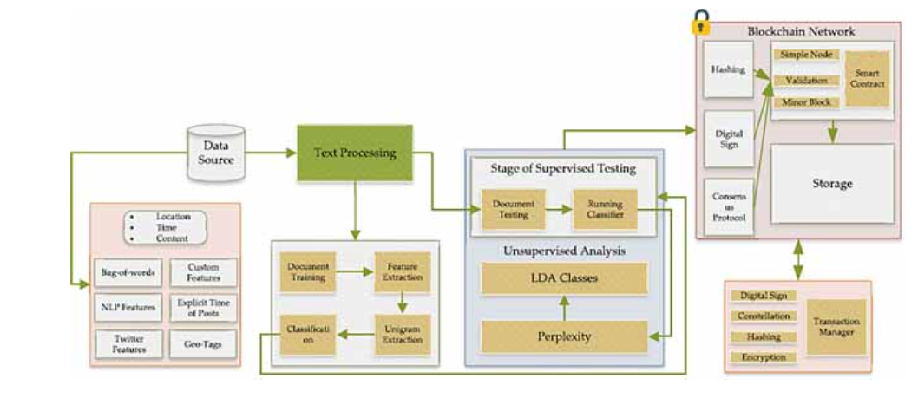
Existing System:
The existing landscape of online information dissemination lacks a comprehensive solution for discerning the veracity of events shared on social media. Traditional platforms heavily rely on centralized servers, making them susceptible to issues such as data tampering, hacking, and the spread of misinformation. Manual verification processes are often time-consuming and labor-intensive. The absence of an automated system for event detection and trust verification leaves users vulnerable to misinformation and hinders the efficient dissemination of reliable information during critical events.
Proposed System:
The proposed system introduces a novel approach to event detection and trust verification by integrating Blockchain technology with NLP and ML techniques. Blockchain, with its decentralized and tamper-proof nature, serves as the foundation for storing and securing event-related data. NLP is applied to analyze textual information, extracting key features for event detection. ML algorithms, including but not limited to Naïve Bayes, Decision Trees, and Neural Networks, are trained on labeled datasets to evaluate and classify events based on their trustworthiness.
The system employs smart contracts in the Blockchain network to facilitate trust verification processes. These contracts contain predefined functions for verifying and validating information stored in the Blockchain, ensuring that events are transparently recorded and accessible to users. The integration of these technologies aims to provide a reliable and automated solution for event detection while enhancing trust verification mechanisms to curb the spread of misinformation.

SYSTEM STUDY FEASIBILITY STUDY

The feasibility of the project is analyzed in this phase and business proposal is put forth with a very general plan for the project and some cost estimates. During system analysis the feasibility study of the proposed system is to be carried out. This is to ensure that the proposed system is not a burden to the company. For feasibility analysis, some understanding of the major requirements for the system is essential.
Three key considerations involved in the feasibility analysis are
- ECONOMICAL FEASIBILITY
- TECHNICAL FEASIBILITY
- SOCIAL FEASIBILITY

ECONOMICAL FEASIBILITY

This study is carried out to check the economic impact that the system will have on the organization. The amount of fund that the company can pour into the research and development of the system is limited. The expenditures must be justified. Thus the developed system as well within the budget and this was achieved because most of the technologies used are freely available. Only the customized products had to be purchased.
TECHNICAL FEASIBILI
This study is carried out to check the technical feasibility, that is, the technical requirements of the system. Any system developed must not have a high demand on the available technical resources. This will lead to high demands on the available technical resources. This will lead to high demands being placed on the client. The developed system must have a modest requirement,

12
as only minimal or null changes are required for implementing this system.

SOCIAL FEASIBILITY

The aspect of study is to check the level of acceptance of the system by the user. This includes the process of training the user to use the system efficiently. The user must not feel threatened by the system, instead must accept it as a necessity. The level of acceptance by the users solely depends on the methods that are employed to educate the user about the system and to make him familiar with it. His level of confidence must be raised so that he is also able to make some constructive criticism, which is welcomed, as he is the final user of the system.

SYSTEM DESIGN
UML DIAGRAMS :

UML stands for Unified Modeling Language. UML is a standardized general-purpose modeling language in the field of object-oriented software engineering. The standard is managed, and was created by, the Object Management Group.
The goal is for UML to become a common language for creating models of object oriented computer software. In its current form UML is comprised of two major components: a Meta-model and a notation. In the future, some form of method or process may also be added to; or associated with, UML.
The Unified Modeling Language is a standard language for specifying, Visualization, Constructing and documenting the artifacts of software system, as well as for business modeling and other non-software systems.
The UML represents a collection of best engineering practices that have proven successful in the modeling of large and complex systems.
The UML is a very important part of developing objects oriented software and the software development process. The UML uses mostly graphical notations to express the design of software projects.

GOALS:
The Primary goals in the design of the UML are as follows:
- Provide users a ready-to-use, expressive visual modeling Language so that they can develop and exchange meaningful models.
- Provide extendibility and specialization mechanisms to extend the core concepts.
- Be independent of particular programming languages and development process.
- Provide a formal basis for understanding the modeling language.
- Encourage the growth of OO tools market.
7
- Support higher level development concepts such as collaborations, frameworks, patterns and components.
- Integrate best practices.

USE CASE DIAGRAM:
A use case diagram in the Unified Modeling Language (UML) is a type of behavioral diagram defined by and created from a Use-case analysis. Its purpose is to present a graphical overview of the functionality provided by a system in terms of actors, their goals (represented as use cases), and any dependencies between those use cases. The main purpose of a use case diagram is to show what system functions are performed for which actor. Roles of the actors in the system can be depicted.

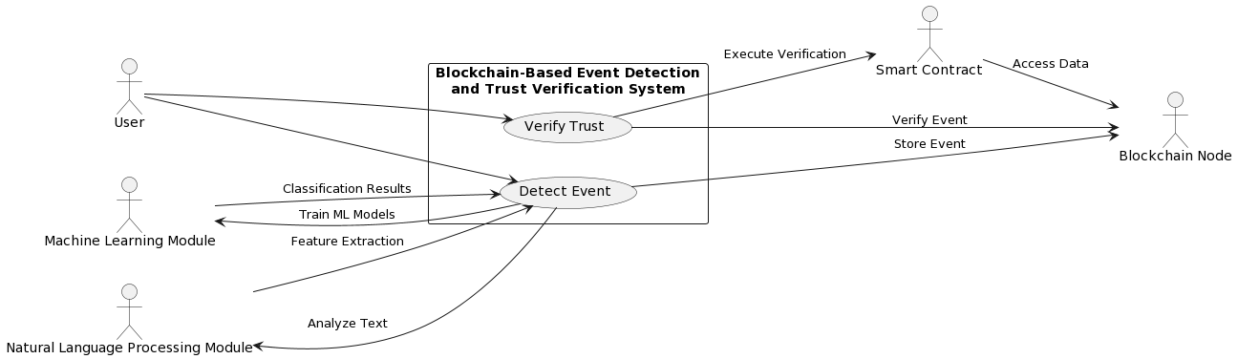
Fig3.1:Use case diagram

CLASS DIAGRAM:
In software engineering, a class diagram in the Unified Modeling Language (UML) is a type of static structure diagram that describes the structure of a system by showing the system's classes, their attributes, operations (or methods), and the relationships among the classes. It explains which class contains information.

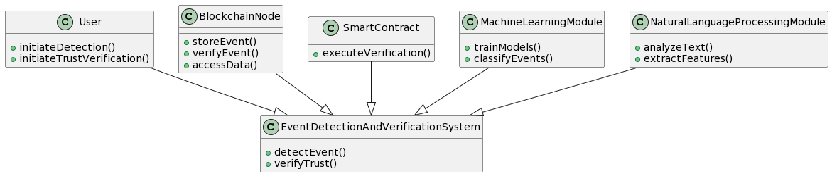
Fig3.2: Class diagram

SEQUENCE DIAGRAM:
A sequence diagram in Unified Modeling Language (UML) is a kind of interaction diagram that shows how processes operate with one another and in what order. It is a construct of a Message Sequence Chart. Sequence diagrams are sometimes called event diagrams, event scenarios, and timing diagrams.

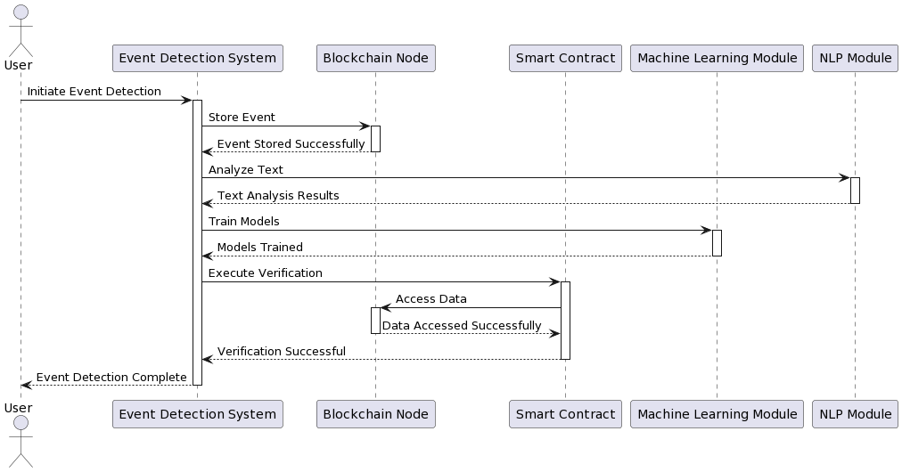

Fig3.3: Sequence diagram

ACTIVITY DIAGRAM:
Activity diagrams are graphical representations of workflows of stepwise activities and actions with support for choice, iteration and concurrency. In the Unified Modeling Language, activity diagrams can be used to describe the business and operational step-by-step workflows of components in a system. An activity diagram shows the overall flow of control.
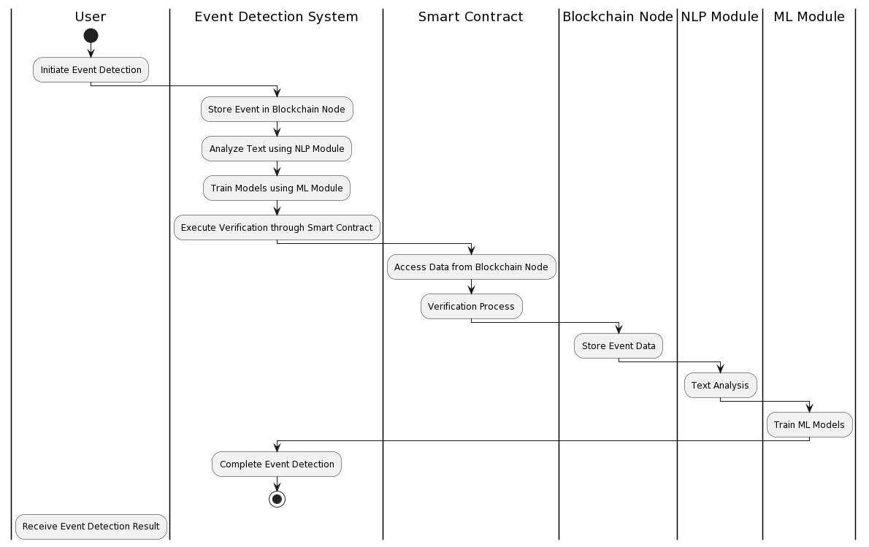

SOFTWARE ENVIRONMENT :
What is Python :
Below are some facts about Python.
Python is currently the most widely used multi-purpose, high-level programming language.
Python allows programming in Object-Oriented and Procedural paradigms. Python programs generally are smaller than other programming languages like Java.
Programmers have to type relatively less and indentation requirement of the language, makes them readable all the time.
Python language is being used by almost all tech-giant companies like – Google, Amazon, Facebook, Instagram, Dropbox, Uber… etc.
The biggest strength of Python is huge collection of standard library which can be used for the following –
  - Machine Learning
  - GUI Applications (like Kivy, Tkinter, PyQt etc. )
  - Web frameworks like Django (used by YouTube, Instagram, Dropbox)
  - Image processing (like Opencv, Pillow)
  - Web scraping (like Scrapy, BeautifulSoup, Selenium)
  - Test frameworks
  - Multimedia

Advantages of Python :-
Let’s see how Python dominates over other languages.

1. Extensive Libraries
Python downloads with an extensive library and it contain code for various purposes like
16
regular expressions, documentation-generation, unit-testing, web browsers, threading, databases, CGI, email, image manipulation, and more. So, we don’t have to write the complete code for that manually.

2. Extensible
As we have seen earlier, Python can be extended to other languages. You can write some of your code in languages like C++ or C. This comes in handy, especially in projects.

3. Embeddable
Complimentary to extensibility, Python is embeddable as well. You can put your Python code in your source code of a different language, like C++. This lets us add scripting capabilities to our code in the other language.

4. Improved Productivity
The language’s simplicity and extensive libraries render programmers more productive than languages like Java and C++ do. Also, the fact that you need to write less and get more things done.

5. IOT Opportunities
Since Python forms the basis of new platforms like Raspberry Pi, it finds the future bright for the Internet Of Things. This is a way to connect the language with the real world.

When working with Java, you may have to create a class to print ‘Hello World’. But in Python, just a print statement will do. It is also quite easy to learn, understand, and code. This is why when people pick up Python, they have a hard time adjusting to other more verbose languages like Java.

7. Readable
Because it is not such a verbose language, reading Python is much like reading English. This is the reason why it is so easy to learn, understand, and code. It also does not need curly braces to define blocks, and indentation is mandatory. This further aids the readability of the code.
17

8. Object-Oriented
This language supports both the procedural and object-oriented programming paradigms. While functions help us with code reusability, classes and objects let us model the real world. A class allows the encapsulation of data and functions into one.

9. Free and Open-Source
Like we said earlier, Python is freely available. But not only can you download Python for free, but you can also download its source code, make changes to it, and even distribute it. It downloads with an extensive collection of libraries to help you with your tasks.

10. Portable
When you code your project in a language like C++, you may need to make some changes to it if you want to run it on another platform. But it isn’t the same with Python. Here, you need to code only once, and you can run it anywhere. This is called Write Once Run Anywhere (WORA). However, you need to be careful enough not to include any system-dependent features.

11. Interpreted
Lastly, we will say that it is an interpreted language. Since statements are executed one by one, debugging is easier than in compiled languages.
Any doubts till now in the advantages of Python? Mention in the comment section.

Advantages of Python Over Other Languages :

1. Less Coding
Almost all of the tasks done in Python requires less coding when the same task is done in other languages. Python also has an awesome standard library support, so you don’t have to search for any third-party libraries to get your job done. This is the reason that many people suggest learning Python to beginners.

2. Affordable
Python is free therefore individuals, small companies or big organizations can leverage the free available resources to build applications. Python is popular and widely used so it gives you better community support. 18
The 2019 Github annual survey showed us that Python has overtaken Java in the most popular programming language category.

3. Python is for Everyone
Python code can run on any machine whether it is Linux, Mac or Windows. Programmers need to learn different languages for different jobs but with Python, you can professionally build web apps, perform data analysis and machine learning, automate things, do web scraping and also build games and powerful visualizations. It is an all-rounder programming language.

Disadvantages of Python
So far, we’ve seen why Python is a great choice for your project. But if you choose it, you should be aware of its consequences as well. Let’s now see the downsides of choosing Python over another language.

1. Speed Limitations
We have seen that Python code is executed line by line. But since Python is interpreted, it often results in slow execution. This, however, isn’t a problem unless speed is a focal point for the project. In other words, unless high speed is a requirement, the benefits offered by Python are enough to distract us from its speed limitations.

2. Weak in Mobile Computing and Browsers
While it serves as an excellent server-side language, Python is much rarely seen on the client-side. Besides that, it is rarely ever used to implement smartphone-based applications. One such application is called Carbonnelle.
The reason it is not so famous despite the existence of Brython is that it isn’t that secure.

3. Design Restrictions
As you know, Python is dynamically-typed. This means that you don’t need to declare the type of variable while writing the code. It uses duck-typing. But wait, what’s that? Well, it just means that if it looks like a duck, it must be a duck.
19

While this is easy on the programmers during coding, it can raise run-time errors.

4. Underdeveloped Database Access Layers
Compared to more widely used technologies like JDBC (Java DataBase Connectivity) and ODBC (Open DataBase Connectivity), Python’s database access layers are a bit underdeveloped. Consequently, it is less often applied in huge enterprises.

5. Simple
No, we’re not kidding. Python’s simplicity can indeed be a problem. Take my example. I don’t do Java, I’m more of a Python person. To me, its syntax is so simple that the verbosity of Java code seems unnecessary.
This was all about the Advantages and Disadvantages of Python Programming Language.

History of Python : -
What do the alphabet and the programming language Python have in common? Right, both start with ABC. If we are talking about ABC in the Python context, it's clear that the programming language ABC is meant. ABC is a general-purpose programming language and programming environment, which had been developed in the Netherlands, Amsterdam, at the CWI (Centrum Wiskunde &Informatica). The greatest achievement of ABC was to influence the design of Python.Python was conceptualized in the late 1980s. Guido van Rossum worked that time in a project at the CWI, called Amoeba, a distributed operating system. In an interview with Bill Venners¹, Guido van Rossum said: "In the early 1980s, I worked as an implementer on a team building a language called ABC at Centrum voor Wiskunde en Informatica (CWI). I don't know how well people know ABC's influence on Python. I try to mention ABC's influence because I'm indebted to everything I learned during that project and to the people who worked on it."Later on in the same Interview, Guido van Rossum continued: "I remembered all my experience and some of my frustration with ABC. I decided to try to design a simple scripting language that possessed some of ABC's better properties, but without its problems. So I started typing. I created a simple virtual machine, a
20
simple parser, and a simple runtime. I made my own version of the various ABC parts that I liked. I created a basic syntax, used indentation for statement grouping instead of curly braces or begin-end blocks, and developed a small number of powerful data types: a hash table (or dictionary, as we call it), a list, strings, and numbers."

What is Machine Learning : -
Before we take a look at the details of various machine learning methods, let's start by looking at what machine learning is, and what it isn't. Machine learning is often categorized as a subfield of artificial intelligence, but I find that categorization can often be misleading at first brush. The study of machine learning certainly arose from research in this context, but in the data science application of machine learning methods, it's more helpful to think of machine learning as a means of building models of data.
Fundamentally, machine learning involves building mathematical models to help understand data. "Learning" enters the fray when we give these models tunable parameters that can be adapted to observed data; in this way the program can be considered to be "learning" from the data. Once these models have been fit to previously seen data, they can be used to predict and understand aspects of newly observed data. I'll leave to the reader the more philosophical digression regarding the extent to which this type of mathematical, model-based "learning" is similar to the "learning" exhibited by the human brain.Understanding the problem setting in machine learning is essential to using these tools effectively, and so we will start with some broad categorizations of the types of approaches we'll discuss here.

Categories Of Machine Leaning :-
At the most fundamental level, machine learning can be categorized into two main types: supervised learning and unsupervised learning.Supervised learning involves somehow modeling the relationship between measured features of data and some label associated with the data; once this model is determined, it can be used to apply labels to new, unknown data. This is further subdivided into classification tasks and regression tasks: in classification, the labels are discrete categories, while in regression, the labels are continuous quantities.
21
We will see examples of both types of supervised learning in the following section.
Unsupervised learning involves modeling the features of a dataset without reference to any label, and is often described as "letting the dataset speak for itself." These models include tasks such as clustering and dimensionality reduction. Clustering algorithms identify distinct groups of data, while dimensionality reduction algorithms search for more succinct representations of the data. We will see examples of both types of unsupervised learning in the following section.

Need for Machine Learning
Human beings, at this moment, are the most intelligent and advanced species on earth because they can think, evaluate and solve complex problems. On the other side, AI is still in its initial stage and haven’t surpassed human intelligence in many aspects. Then the question is that what is the need to make machine learn? The most suitable reason for doing this is, “to make decisions, based on data, with efficiency and scale”.
Lately, organizations are investing heavily in newer technologies like Artificial Intelligence, Machine Learning and Deep Learning to get the key information from data to perform several real-world tasks and solve problems. We can call it data-driven decisions taken by machines, particularly to automate the process. These data-driven decisions can be used, instead of using programing logic, in the problems that cannot be programmed inherently. The fact is that we can’t do without human intelligence, but other aspect is that we all need to solve real-world problems with efficiency at a huge scale. That is why the need for machine learning arises.

Challenges in Machines Learning :-
While Machine Learning is rapidly evolving, making significant strides with cybersecurity and autonomous cars, this segment of AI as whole still has a long way to go. The reason behind is that ML has not been able to overcome number of challenges. The challenges that ML is facing currently are −

22
Quality of data − Having good-quality data for ML algorithms is one of the biggest challenges. Use of low-quality data leads to the problems related to data preprocessing and feature extraction.
Time-Consuming task − Another challenge faced by ML models is the consumption of time especially for data acquisition, feature extraction and retrieval.
Lack of specialist persons − As ML technology is still in its infancy stage, availability of expert resources is a tough job.
No clear objective for formulating business problems − Having no clear objective and well-defined goal for business problems is another key challenge for ML because this technology is not that mature yet.
Issue of overfitting & underfitting − If the model is overfitting or underfitting, it cannot be represented well for the problem.
Curse of dimensionality − Another challenge ML model faces is too many features of data points. This can be a real hindrance.
Difficulty in deployment − Complexity of the ML model makes it quite difficult to be deployed in real life.

Applications of Machines Learning :-
Machine Learning is the most rapidly growing technology and according to researchers we are in the golden year of AI and ML. It is used to solve many real-world complex problems which cannot be solved with traditional approach. Following are some real-world applications of ML −
- Emotion analysis
- Sentiment analysis
- Error detection and prevention
- Weather forecasting and prediction
- Stock market analysis and forecasting
- Speech synthesis 23
- Speech recognition
- Customer segmentation
- Object recognition
- Fraud detection
- Fraud prevention
- Recommendation of products to customer in online shopping.

How to Start Learning Machine Learning?
Arthur Samuel coined the term “Machine Learning” in 1959 and defined it as a “Field of study that gives computers the capability to learn without being explicitly programmed”.
And that was the beginning of Machine Learning! In modern times, Machine Learning is one of the most popular (if not the most!) career choices. According to Indeed, Machine Learning Engineer Is The Best Job of 2019 with a 344% growth and an average base salary of $146,085 per year.
But there is still a lot of doubt about what exactly is Machine Learning and how to start learning it? So this article deals with the Basics of Machine Learning and also the path you can follow to eventually become a full-fledged Machine Learning Engineer. Now let’s get started!!!

How to start learning ML?
This is a rough roadmap you can follow on your way to becoming an insanely talented Machine Learning Engineer. Of course, you can always modify the steps according to your needs to reach your desired end-goal!
Step 1 – Understand the Prerequisite : case you are a genius, you could start ML directly but normally, there are some prerequisites that you need to know which include Linear Algebra, Multivariate Calculus, Statistics, and Python. And if you don’t know these, never fear! You don’t need a Ph.D. degree in these topics to get started but you do need a basic understanding.
24

(a) Learn Linear Algebra and Multivariate Calculus
Both Linear Algebra and Multivariate Calculus are important in Machine Learning. However, the extent to which you need them depends on your role as a data scientist. If you are more focused on application heavy machine learning, then you will not be that heavily focused on maths as there are many common libraries available. But if you want to focus on R&D in Machine Learning, then mastery of Linear Algebra and Multivariate Calculus is very important as you will have to implement many ML algorithms from scratch.

(b) Learn Statistics
Data plays a huge role in Machine Learning. In fact, around 80% of your time as an ML expert will be spent collecting and cleaning data. And statistics is a field that handles the collection, analysis, and presentation of data. So it is no surprise that you need to learn it!!!
Some of the key concepts in statistics that are important are Statistical Significance, Probability Distributions, Hypothesis Testing, Regression, etc. Also, Bayesian Thinking is also a very important part of ML which deals with various concepts like Conditional Probability, Priors, and Posteriors, Maximum Likelihood, etc.

(c) Learn Python
Some people prefer to skip Linear Algebra, Multivariate Calculus and Statistics and learn them as they go along with trial and error. But the one thing that you absolutely cannot skip is Python! While there are other languages you can use for Machine Learning like R, Scala, etc. Python is currently the most popular language for ML. In fact, there are many Python libraries that are specifically useful for Artificial Intelligence and Machine Learning such as Keras, TensorFlow, Scikit-learn, etc.
So if you want to learn ML, it’s best if you learn Python! You can do that using various online resources and courses such as Fork Python available Free on GeeksforGeeks.

25

Step 2 – Learn Various ML Concepts
Now that you are done with the prerequisites, you can move on to actually learning ML (Which is the fun part!!!) It’s best to start with the basics and then move on to the more complicated stuff. Some of the basic concepts in ML are:

(a) Terminologies of Machine Learning
- Model – A model is a specific representation learned from data by applying some machine learning algorithm. A model is also called a hypothesis.
- Feature – A feature is an individual measurable property of the data. A set of numeric features can be conveniently described by a feature vector. Feature vectors are fed as input to the model. For example, in order to predict a fruit, there may be features like color, smell, taste, etc.
- Target (Label) – A target variable or label is the value to be predicted by our model. For the fruit example discussed in the feature section, the label with each set of input would be the name of the fruit like apple, orange, banana, etc.
- Training – The idea is to give a set of inputs(features) and it’s expected outputs(labels), so after training, we will have a model (hypothesis) that will then map new data to one of the categories trained on.
- Prediction – Once our model is ready, it can be fed a set of inputs to which it will provide a predicted output(label).

(b) Types of Machine Learning
- Supervised Learning – This involves learning from a training dataset with labeled data using classification and regression models. This learning process continues until the required level of performance is achieved.
- Unsupervised Learning – This involves using unlabelled data and then finding the underlying structure in the data in order to learn more and more about the data itself using factor and cluster analysis models.
26
- Semi-supervised Learning – This involves using unlabelled data like Unsupervised Learning with a small amount of labeled data. Using labeled data vastly increases the learning accuracy and is also more cost-effective than Supervised Learning.
- Reinforcement Learning – This involves learning optimal actions through trial and error. So the next action is decided by learning behaviors that are based on the current state and that will maximize the reward in the future.

Advantages of Machine learning :-

1. Easily identifies trends and patterns -
Machine Learning can review large volumes of data and discover specific trends and patterns that would not be apparent to humans. For instance, for an e-commerce website like Amazon, it serves to understand the browsing behaviors and purchase histories of its users to help cater to the right products, deals, and reminders relevant to them. It uses the results to reveal relevant advertisements to them.

2. No human intervention needed (automation)
With ML, you don’t need to babysit your project every step of the way. Since it means giving machines the ability to learn, it lets them make predictions and also improve the algorithms on their own. A common example of this is anti-virus softwares; they learn to filter new threats as they are recognized. ML is also good at recognizing spam.

3. Continuous Improvement
As ML algorithms gain experience, they keep improving in accuracy and efficiency. This lets them make better decisions. Say you need to make a weather forecast model. As the amount of data you have keeps growing, your algorithms learn to make more accurate predictions faster.

4. Handling multi-dimensional and multi-variety data
Machine Learning algorithms are good at handling data that are multi-dimensional and multi-variety, and they can do this in dynamic or uncertain environments.
27

5. Wide Applications
You could be an e-tailer or a healthcare provider and make ML work for you. Where it does apply, it holds the capability to help deliver a much more personal experience to customers while also targeting the right customers.

Disadvantages of Machine Learning :-

1. Data Acquisition
Machine Learning requires massive data sets to train on, and these should be inclusive/unbiased, and of good quality. There can also be times where they must wait for new data to be generated.

2. Time and Resources
ML needs enough time to let the algorithms learn and develop enough to fulfill their purpose with a considerable amount of accuracy and relevancy. It also needs massive resources to function. This can mean additional requirements of computer power for you.

3. Interpretation of Results
Another major challenge is the ability to accurately interpret results generated by the algorithms. You must also carefully choose the algorithms for your purpose.

4. High error-susceptibility
Machine Learning is autonomous but highly susceptible to errors. Suppose you train an algorithm with data sets small enough to not be inclusive. You end up with biased predictions coming from a biased training set. This leads to irrelevant advertisements being displayed to customers. In the case of ML, such blunders can set off a chain of errors that can go undetected for long periods of time. And when they do get noticed, it takes quite some time to recognize the source of the issue, and even longer to correct it.
Python Development Steps : -
Guido Van Rossum published the first version of Python code (version 0.9.0) at alt.sources in
28
February 1991. This release included already exception handling, functions, and the core data types of list, dict, str and others. It was also object oriented and had a module system.
Python version 1.0 was released in January 1994. The major new features included in this release were the functional programming tools lambda, map, filter and reduce, which Guido Van Rossum never liked.Six and a half years later in October 2000, Python 2.0 was introduced. This release included list comprehensions, a full garbage collector and it was supporting unicode.Python flourished for another 8 years in the versions 2.x before the next major release as Python 3.0 (also known as "Python 3000" and "Py3K") was released. Python 3 is not backwards compatible with Python 2.x. The emphasis in Python 3 had been on the removal of duplicate programming constructs and modules, thus fulfilling or coming close to fulfilling the 13th law of the Zen of Python: "There should be one -- and preferably only one -- obvious way to do it."Some changes in Python 7.3:
- Print is now a function
- Views and iterators instead of lists
- The rules for ordering comparisons have been simplified. E.g. a heterogeneous list cannot be sorted, because all the elements of a list must be comparable to each other.
- There is only one integer type left, i.e. int. long is int as well.
- The division of two integers returns a float instead of an integer. "//" can be used to have the "old" behaviour.
- Text Vs. Data Instead Of Unicode Vs. 8-bit
Purpose :-
We demonstrated that our approach enables successful segmentation of intra-retinal layers—even with low-quality images containing speckle noise, low contrast, and different intensity ranges throughout—with the assistance of the ANIS feature.
Python
Python is an interpreted high-level programming language for general-purpose programming. Created by Guido van Rossum and first released in 1991, Python has a design philosophy
29
that emphasizes code readability, notably using significant whitespace.
Python features a dynamic type system and automatic memory management. It supports multiple programming paradigms, including object-oriented, imperative, functional and procedural, and has a large and comprehensive standard library.
- Python is Interpreted − Python is processed at runtime by the interpreter. You do not need to compile your program before executing it. This is similar to PERL and PHP.
- Python is Interactive − you can actually sit at a Python prompt and interact with the interpreter directly to write your programs.
Python also acknowledges that speed of development is important. Readable and terse code is part of this, and so is access to powerful constructs that avoid tedious repetition of code. Maintainability also ties into this may be an all but useless metric, but it does say something about how much code you have to scan, read and/or understand to troubleshoot problems or tweak behaviors. This speed of development, the ease with which a programmer of other languages can pick up basic Python skills and the huge standard library is key to another area where Python excels. All its tools have been quick to implement, saved a lot of time, and several of them have later been patched and updated by people with no Python background - without breaking.
Modules Used in Project :-
Tensorflow
TensorFlow is a free and open-source software library for dataflow and differentiable programming across a range of tasks. It is a symbolic math library, and is also used for machine learning applications such as neural networks. It is used for both research and production at Google.‍
TensorFlow was developed by the Google Brain team for internal Google use. It was released under the Apache 2.0 open-source license on November 9, 2015.
Numpy : Numpy is a general-purpose array-processing package. It provides a high-performance
30

multidimensional array object, and tools for working with these arrays.
It is the fundamental package for scientific computing with Python. It contains various features including these important ones:
- A powerful N-dimensional array object
- Sophisticated (broadcasting) functions
- Tools for integrating C/C++ and Fortran code
- Useful linear algebra, Fourier transform, and random number capabilities
Besides its obvious scientific uses, Numpy can also be used as an efficient multi-dimensional container of generic data. Arbitrary data-types can be defined using Numpy which allows Numpy to seamlessly and speedily integrate with a wide variety of databases.
Pandas
Pandas is an open-source Python Library providing high-performance data manipulation and analysis tool using its powerful data structures. Python was majorly used for data munging and preparation. It had very little contribution towards data analysis. Pandas solved this problem. Using Pandas, we can accomplish five typical steps in the processing and analysis of data, regardless of the origin of data load, prepare, manipulate, model, and analyze. Python with Pandas is used in a wide range of fields including academic and commercial domains including finance, economics, Statistics, analytics, etc.
Matplotlib
Matplotlib is a Python 2D plotting library which produces publication quality figures in a variety of hardcopy formats and interactive environments across platforms. Matplotlib can be used in Python scripts, the Python and IPython shells, the Jupyter Notebook, web application servers, and four graphical user interface toolkits. Matplotlib tries to make easy things easy and hard things possible. You can generate plots, histograms, power spectra, bar charts, error charts, scatter plots, etc., with just a few lines of code. For examples, see the sample plots and thumbnail gallery.
31
For simple plotting the pyplot module provides a MATLAB-like interface, particularly when combined with IPython. For the power user, you have full control of line styles, font properties, axes properties, etc, via an object oriented interface or via a set of functions familiar to MATLAB users.
Scikit – learn
Scikit-learn provides a range of supervised and unsupervised learning algorithms via a consistent interface in Python. It is licensed under a permissive simplified BSD license and is distributed under many Linux distributions, encouraging academic and commercial use. Python
Python is an interpreted high-level programming language for general-purpose programming. Created by Guido van Rossum and first released in 1991, Python has a design philosophy that emphasizes code readability, notably using significant whitespace.
Python features a dynamic type system and automatic memory management. It supports multiple programming paradigms, including object-oriented, imperative, functional and procedural, and has a large and comprehensive standard library.
- Python is Interpreted − Python is processed at runtime by the interpreter. You do not need to compile your program before executing it. This is similar to PERL and PHP.
- Python is Interactive − you can actually sit at a Python prompt and interact with the interpreter directly to write your programs.
Python also acknowledges that speed of development is important. Readable and terse code is part of this, and so is access to powerful constructs that avoid tedious repetition of code. Maintainability also ties into this may be an all but useless metric, but it does say something about how much code you have to scan, read and/or understand to troubleshoot problems or tweak behaviors. This speed of development, the ease with which a programmer of other languages can pick up basic Python skills and the huge standard library is key to another area where Python excels. All its tools have been quick to implement, saved a lot of time, and several of them have later been patched and updated by people with no Python background - without breaking.
32

Install Python Step-by-Step in Windows and Mac :
Python a versatile programming language doesn’t come pre-installed on your computer devices. Python was first released in the year 1991 and until today it is a very popular high-level programming language. Its style philosophy emphasizes code readability with its notable use of great whitespace.
The object-oriented approach and language construct provided by Python enables programmers to write both clear and logical code for projects. This software does not come pre-packaged with Windows.

How to Install Python on Windows and Mac :

There have been several updates in the Python version over the years. The question is how to install Python? It might be confusing for the beginner who is willing to start learning Python but this tutorial will solve your query. The latest or the newest version of Python is version 3.7.4 or in other words, it is Python 3.
Note: The python version 3.7.4 cannot be used on Windows XP or earlier devices.

Before you start with the installation process of Python. First, you need to know about your System Requirements. Based on your system type i.e. operating system and based processor, you must download the python version. My system type is a Windows 64-bit operating system. So the steps below are to install python version 3.7.4 on Windows 7 device or to install Python 3. Download the Python Cheatsheet here.The steps on how to install Python on Windows 10, 8 and 7 are divided into 4 parts to help understand better.

Download the Correct version into the system
Step 1: Go to the official site to download and install python using Google Chrome or any other web browser. OR Click on the following link: https://www.python.org
33

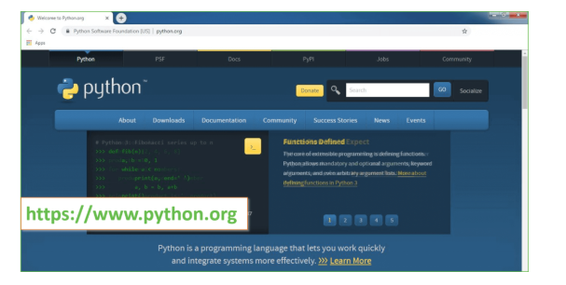
Now, check for the latest and the correct version for your operating system.
Step 2: Click on the Download Tab.
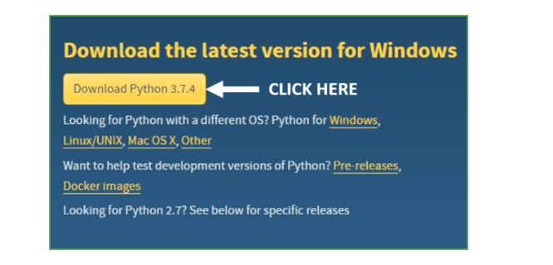
34
Step 3: You can either select the Download Python for windows 3.7.4 button in Yellow Color or you can scroll further down and click on download with respective to their version. Here, we are downloading the most recent python version for windows 3.7.4
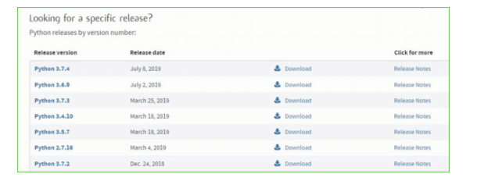
Step 4: Scroll down the page until you find the Files option.

Step 5: Here you see a different version of python along with the operating system.

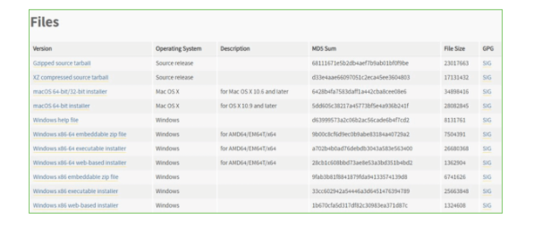

35
• To download Windows 32-bit python, you can select any one from the three options: Windows x86 embeddable zip file, Windows x86 executable installer or Windows x86 web-based installer.
•To download Windows 64-bit python, you can select any one from the three options: Windows x86-64 embeddable zip file, Windows x86-64 executable installer or Windows x86-64 web-based installer.
Here we will install Windows x86-64 web-based installer. Here your first part regarding which version of python is to be downloaded is completed. Now we move ahead with the second part in installing python i.e. Installation
Note: To know the changes or updates that are made in the version you can click on the Release Note Option.

Installation of Python
Step 1: Go to Download and Open the downloaded python version to carry out the installation process.
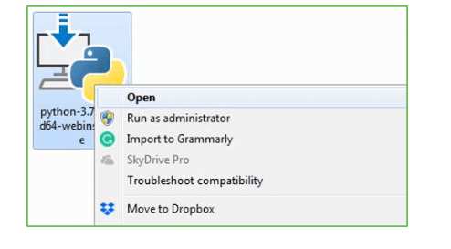
Step 2: Before you click on Install Now, Make sure to put a tick on Add Python 3.7 to PATH.

36
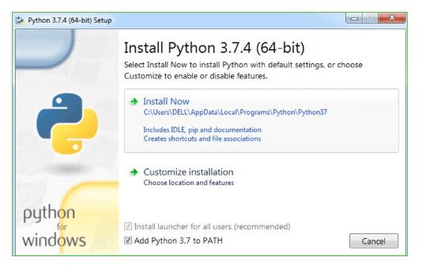

Step 3: Click on Install NOW After the installation is successful. Click on Close.
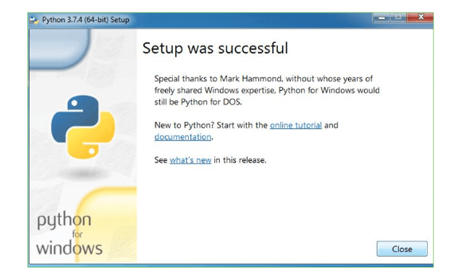

With these above three steps on python installation, you have successfully and correctly installed Python. Now is the time to verify the installation.
37
Note: The installation process might take a couple of minutes.

Verify the Python Installation
Step 1: Click on Start
Step 2: In the Windows Run Command, type “cmd”.

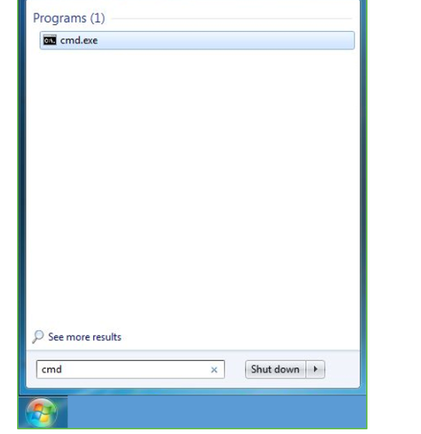
Step 3: Open the Command prompt option.
Step 4: Let us test whether the python is correctly installed. Type python –V and press Enter.

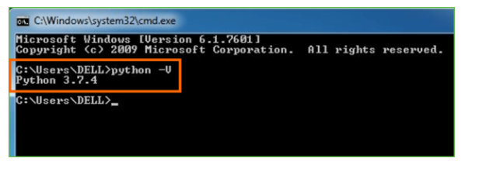
Step 5: You will get the answer as 3.7.4
38
Note: If you have any of the earlier versions of Python already installed. You must first uninstall the earlier version and then install the new one.

Check how the Python IDLE works
Step 1: Click on Start
Step 2: In the Windows Run command, type “python idle”.
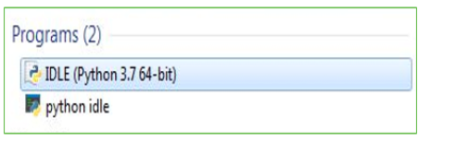
Step 3: Click on IDLE (Python 3.7 64-bit) and launch the program
Step 4: To go ahead with working in IDLE you must first save the file. Click on File > Click on Save

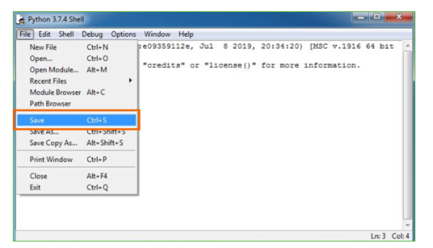
Step 5: Name the file and save as type should be Python files. Click on SAVE. Here I have named the files as Hey World.
Step 6: Now for e.g. enter print38

CHAPETER 6
SYSTEM TEST
The purpose of testing is to discover errors. Testing is the process of trying to discover every conceivable fault or weakness in a work product. It provides a way to check the functionality of components, sub assemblies, assemblies and/or a finished product It is the process of exercising software with the intent of ensuring that the Software system meets its requirements and user expectations and does not fail in an unacceptable manner. There are various types of test. Each test type addresses a specific testing requirement.

TYPES OF TESTS

Unit testing
Unit testing involves the design of test cases that validate that the internal program logic is functioning properly, and that program inputs produce valid outputs. All decision branches and internal code flow should be validated. It is the testing of individual software units of the application .it is done after the completion of an individual unit before integration. This is a structural testing, that relies on knowledge of its construction and is invasive. Unit tests perform basic tests at component level and test a specific business process, application, and/or system configuration. Unit tests ensure that each unique path of a business process performs accurately to the documented specifications and contains clearly defined inputs and expected results.

Integration testing
Integration tests are designed to test integrated software components to determine if they actually run as one program. Testing is event driven and is more concerned with the basic outcome of screens or fields. Integration tests demonstrate that although the components were individually satisfaction, as shown by successfully unit testing, the combination of components is correct and consistent. Integration testing is specifically aimed at exposing the problems that arise from the combination of components.

39

Functional test

Functional tests provide systematic demonstrations that functions tested are available as specified by the business and technical requirements, system documentation, and user manuals.
Functional testing is centered on the following items:
Valid Input : identified classes of valid input must be accepted.
Invalid Input : identified classes of invalid input must be rejected.
Functions : identified functions must be exercised.
Output : identified classes of application outputs must be exercised.
Systems/Procedures : interfacing systems or procedures must be invoked.
Organization and preparation of functional tests is focused on requirements, key functions, or special test cases. In addition, systematic coverage pertaining to identify Business process flows; data fields, predefined processes, and successive processes must be considered for testing. Before functional testing is complete, additional tests are identified and the effective value of current tests is determined.

System Test
System testing ensures that the entire integrated software system meets requirements. It tests a configuration to ensure known and predictable results. An example of system testing is the configuration oriented system integration test. System testing is based on process descriptions and flows, emphasizing pre-driven process links and integration points.

White Box Testing
White Box Testing is a testing in which in which the software tester has knowledge of the inner workings, structure and language of the software, or at least its purpose. It is purpose. It is used to test areas that cannot be reached from a black box level.

40

Black Box Testing

Black Box Testing is testing the software without any knowledge of the inner workings, structure or language of the module being tested. Black box tests, as most other kinds of tests, must be written from a definitive source document, such as specification or requirements document, such as specification or requirements document. It is a testing in which the software under test is treated, as a black box .you cannot “see” into it. The test provides inputs and responds to outputs without considering how the software works.

Unit Testing
Unit testing is usually conducted as part of a combined code and unit test phase of the software lifecycle, although it is not uncommon for coding and unit testing to be conducted as two distinct phases.
Test strategy and approach
Field testing will be performed manually and functional tests will be written in detail.
Test objectives
- All field entries must work properly.
- Pages must be activated from the identified link.
- The entry screen, messages and responses must not be delayed.

Features to be tested
- Verify that the entries are of the correct format
- No duplicate entries should be allowed
- All links should take the user to the correct page.

Integration Testing
41
Software integration testing is the incremental integration testing of two or more integrated software components on a single platform to produce failures caused by interface defects.
The task of the integration test is to check that components or software applications, e.g. components in a software system or – one step up – software applications at the company level – interact without error.
Test Results:All the test cases mentioned above passed successfully. No defects encountered.

Acceptance Testing
User Acceptance Testing is a critical phase of any project and requires significant participation by the end user. It also ensures that the system meets the functional requirements.
Test Results:All the test cases mentioned above passed successfully. No defects encountered.

Online social media’s are heavily utilizing to post small messages and this messages often contains information of different events like natural disaster. Automatic classification of posts messages will help emergency relief team in knowing number of detected disaster and based on detection team will manage their work. Propose work will apply Natural Language processing Text API to analyse text and then convert text into training features. Training features will be input to different machine learning to evaluate their performance for classification. In propose work author has evaluated 8 different algorithms such as Naïve Bayes, KNN, SVM, Decision Tree, Random Forest, XGBOOST, Logistic Regression and Deep Learning. Among all algorithms Deep Learning is giving best accuracy. Each algorithm is evaluated in terms of accuracy, precision, recall and FCSORE.
All social media are dependent on Centralized single server to store users post and if this server crash or hack then services will get disturbed. To overcome from this issue author of this paper employing Blockchain based Decentralized server which will store data in multiple nodes and if one node down then user can access services from other working nodes.
All users POST stored in Blockchain will be tamper proof as Blockchain has inbuilt support of data encryption and leakage. Blockchain store each record as Block/transaction and associate each block with unique hash code. While storing news record Blockchain will verify all previous hash codes and if data not alter then hash code verification will be successful, if data alter then verification get failed and data alter will get detected and due to this reason Blockchain is known as tamper proof.
Blockchain store and get data by smart contract and this contract contains functions to save and get data. To store user posts we have designed following contract.
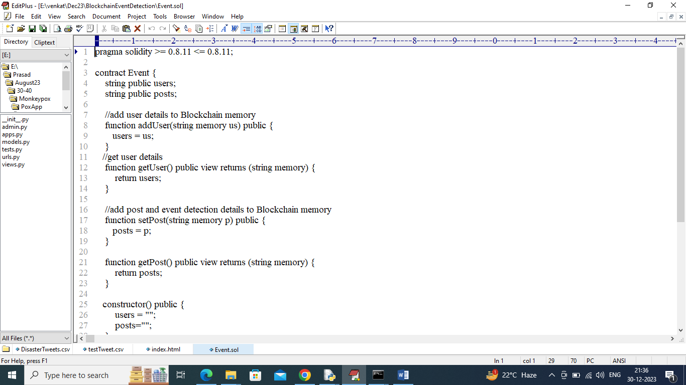
In above contract we have defined functions to save user and post details and now we need to deploy above contract to Blockchain Ethereum by following below steps
- First go inside ‘hello-eth/node-modules/bin’ folder and then find and double click on ‘runBlockchain.bat’ file to start Blockchain server and get below screen
- 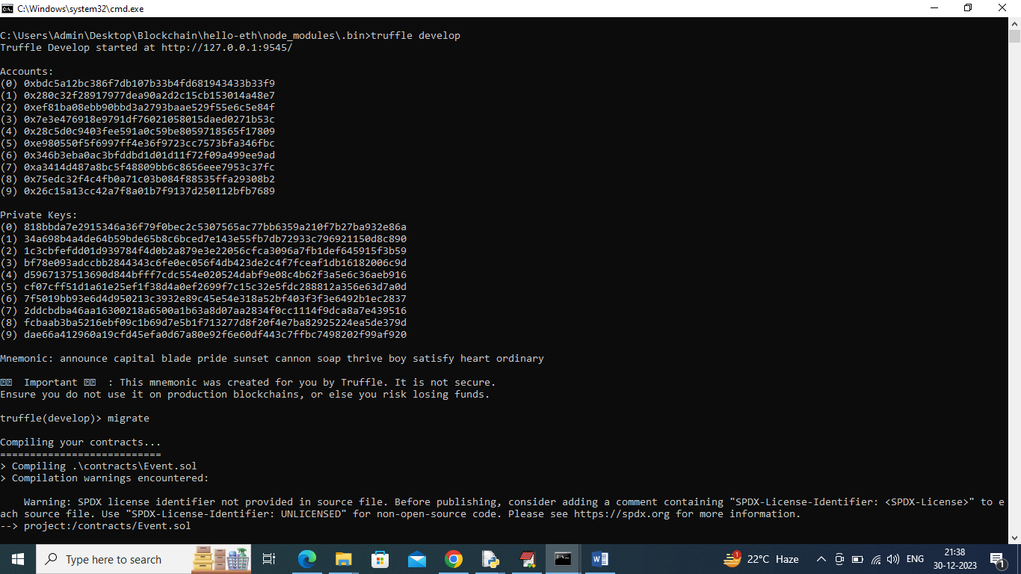
- In above screen Blockchain started with default Private keys and accounts and now type command as ‘migrate’ and then press enter key to get below page
- 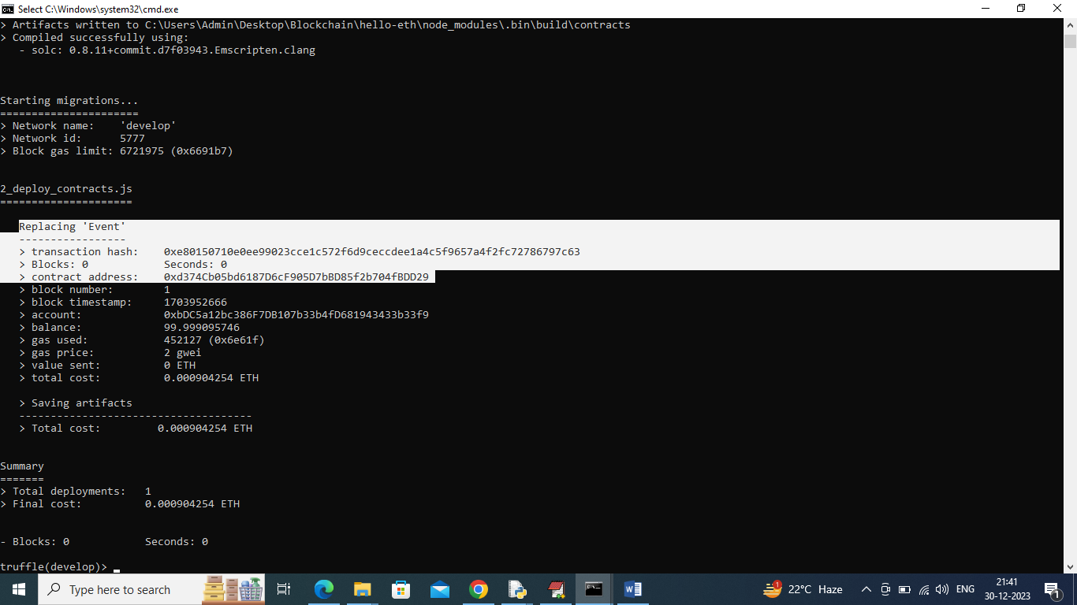
- In above screen in white colour text can see ‘Event’ contract deployed and got contract address also and this contract address need to specify in python code to call Smart contract function. In below screen can see python calling Blockchain contract by using address
- 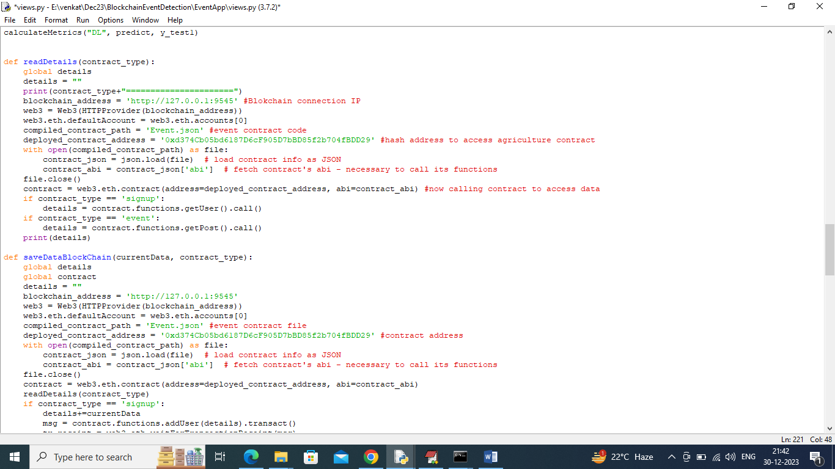
- In above screen read red colour text to know about contract calling and now contract deployed and running in Black console and let it run.
Dataset Details
To train ML and DL algorithms we have used Disaster Event tweets dataset which can be crawled or download using Google API and below is the dataset sample screen
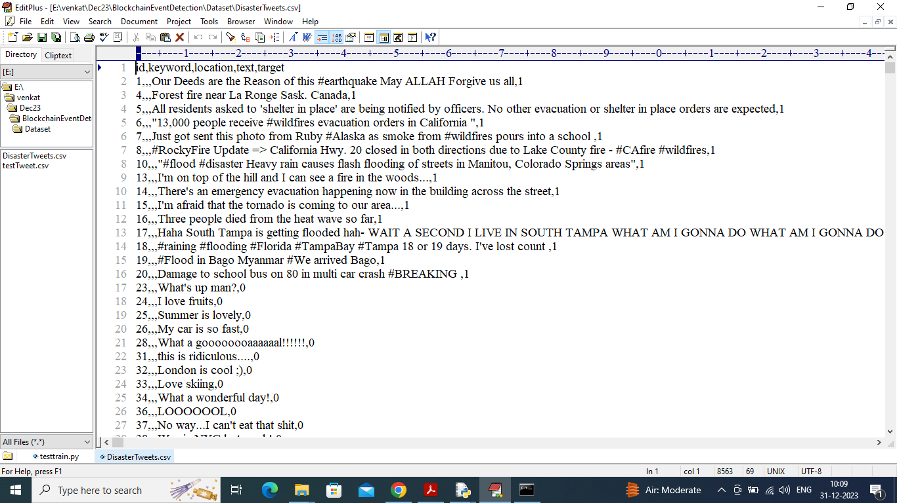
In above dataset screen first row represents dataset column names and remaining rows represents dataset values and in above dataset can see tweet text and last column contains target value as 0 or 1 where 0 represents Normal Event and 1 represents Disaster Event
SCREEN SHOTS
To run code double click on ‘run.bat’ file to start python server and get below screen
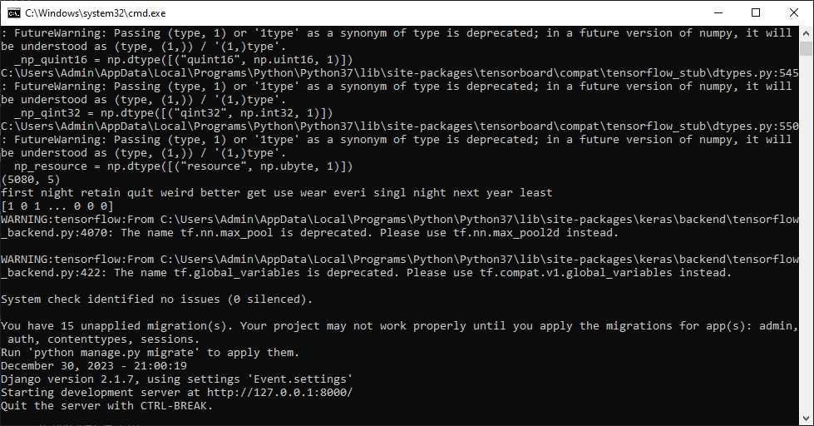
In above screen python server started and now open browser and enter URL as http://127.0.0.1:8000/index. Html and press enter key to get below page
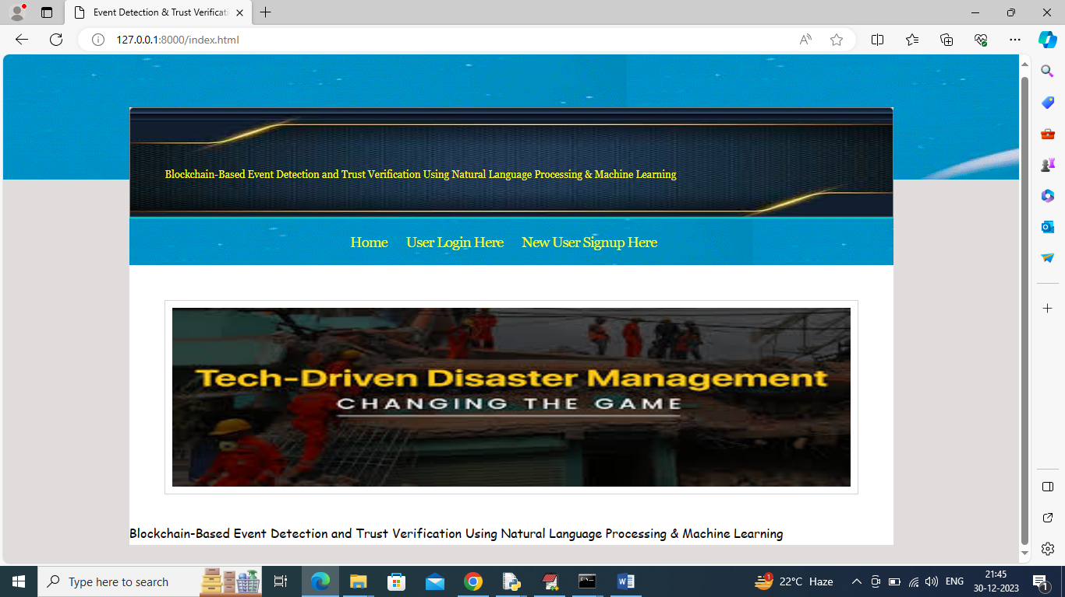
In above screen click on ‘New User Signup Here’ link to get below page
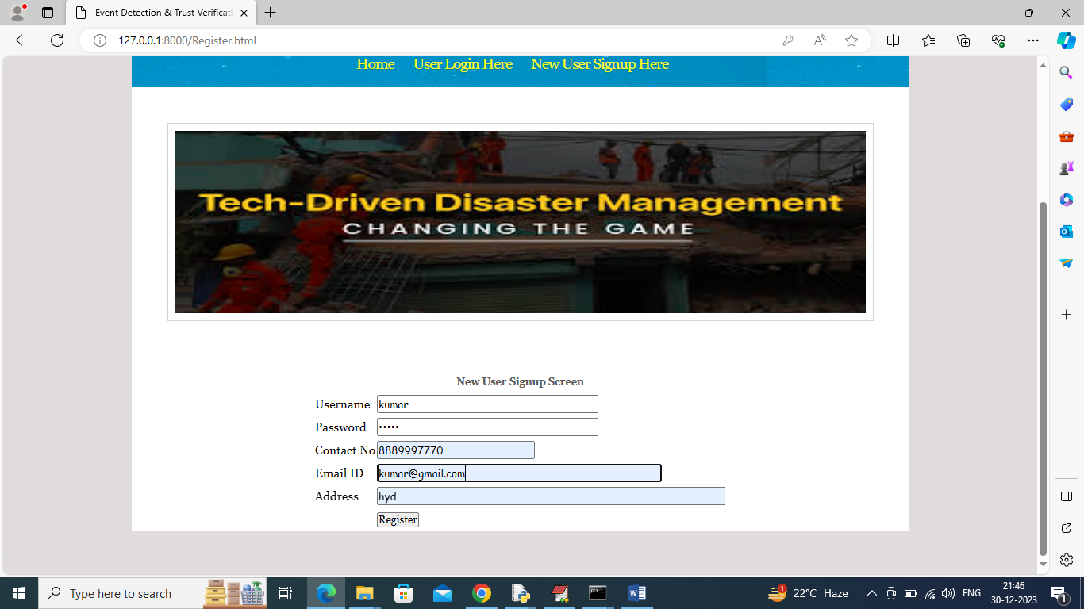
In above screen user is entering signup details and then press button to get below page
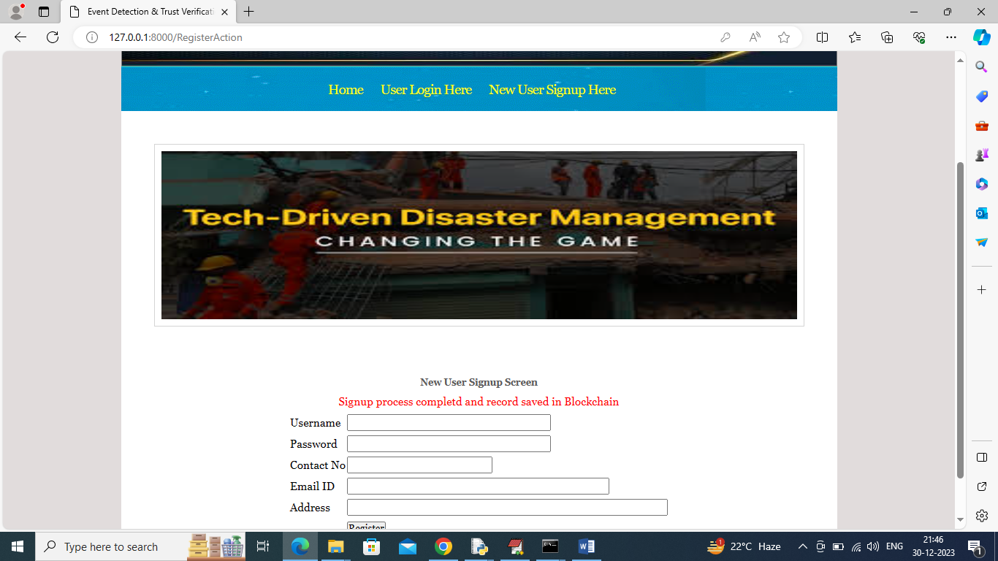
In above screen signup task completed and similarly you can add as many users as you want. Now click on ‘User Login Here’ link to get below page
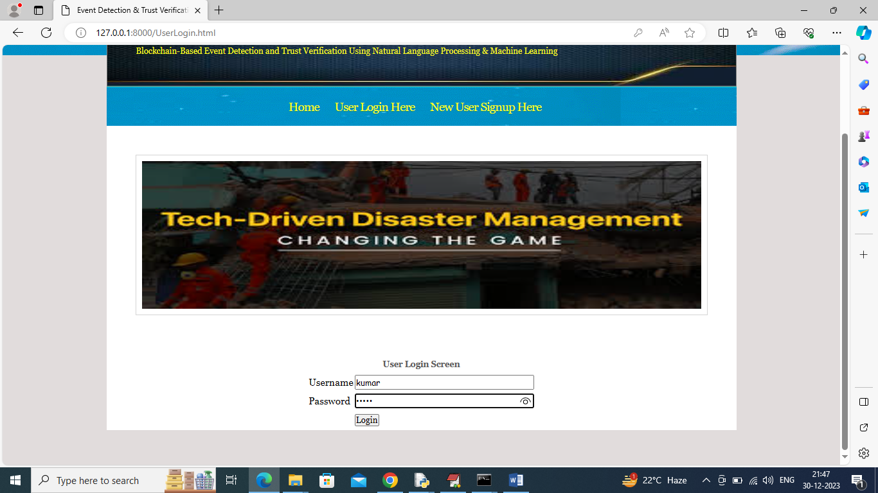
In above screen user is login and after login will get below page
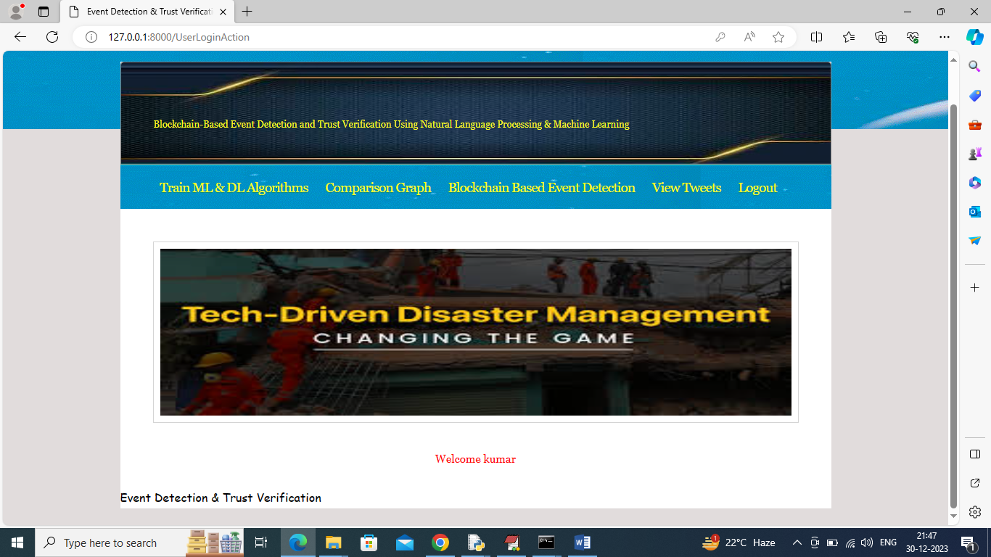
In above screen click on ‘Train ML & DL Algorithms’ link to get below page
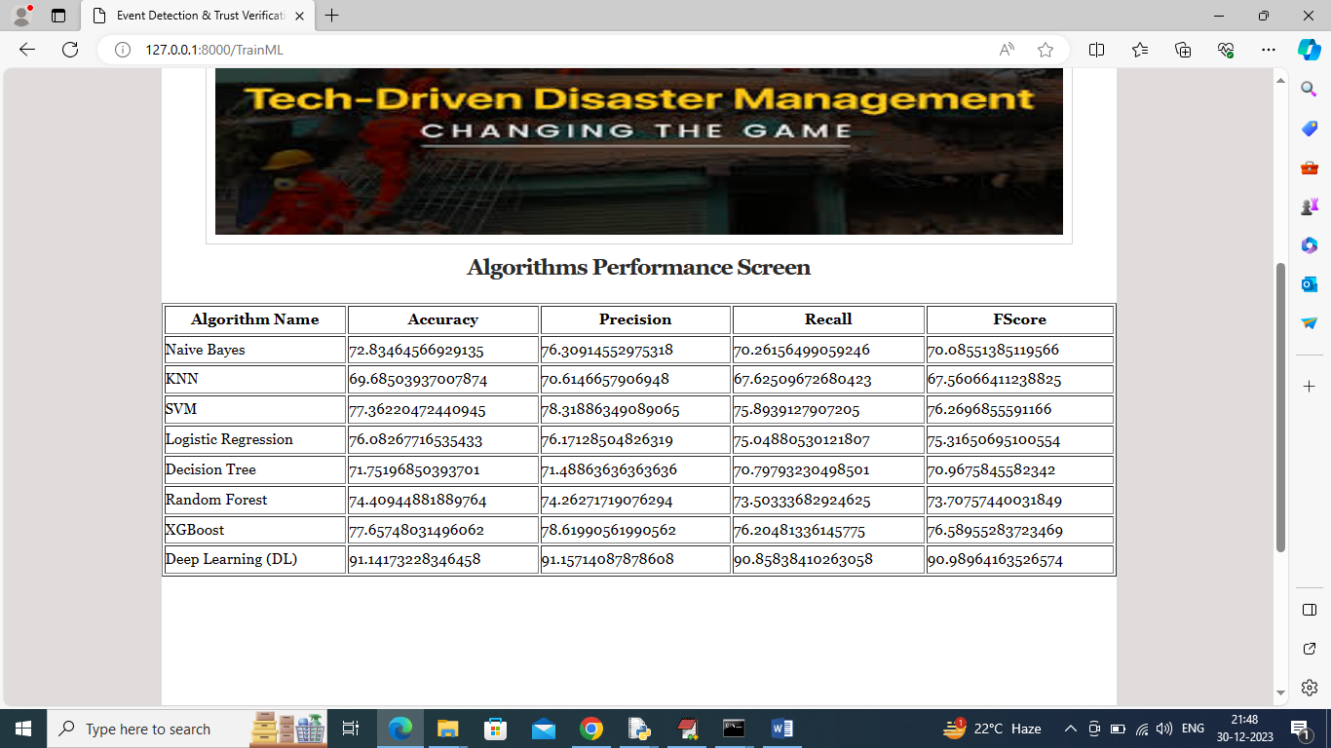
In above screen all algorithms training completed and can see performance of each algorithm and in all algorithms Deep Learning algorithm has got high accuracy and now click on ‘Comparison Graph’ link to get below page
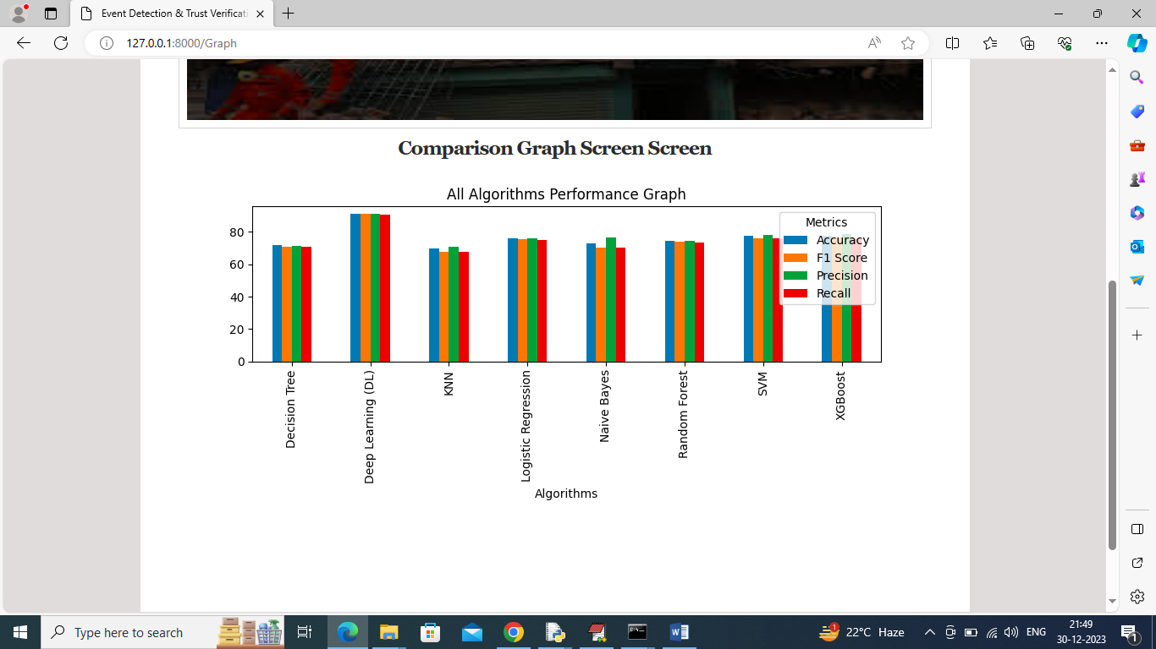
In above graph x-axis represents algorithm names and y-axis represents accuracy, precision and other metrics in different colour bars and in all algorithms Deep Learning got high performance. Now click on ‘Blockchain Based event Detection’ link to get below page
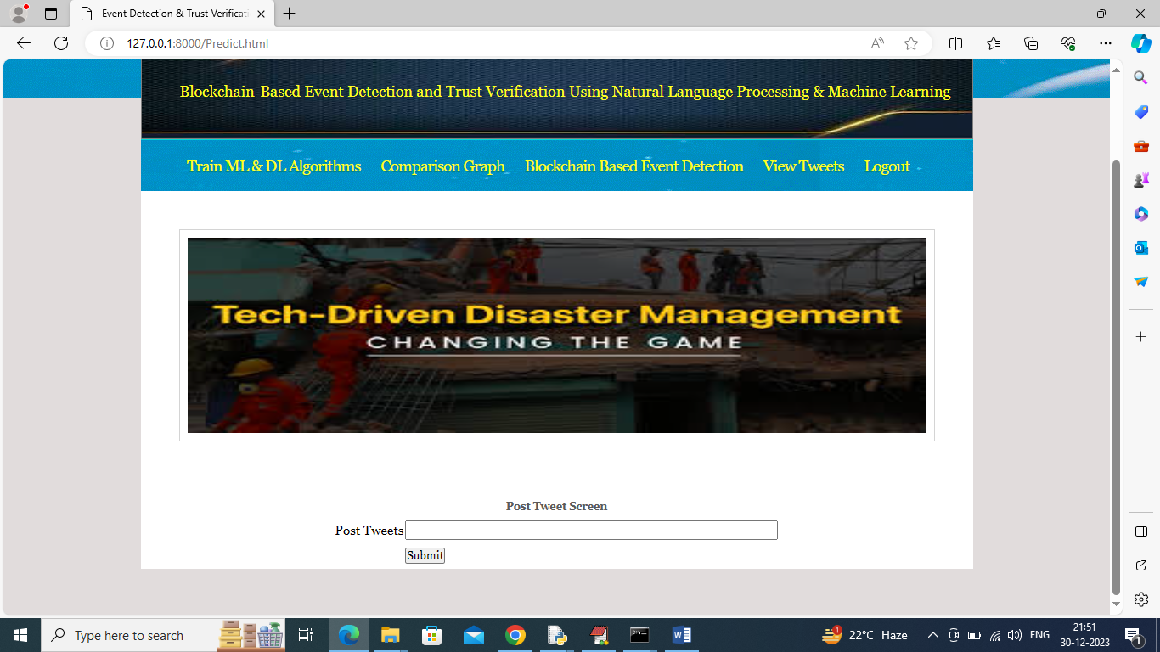
In above screen user can enter some post and this post will get saved in Blockchain and ML algorithms will predict weather tweet is ‘Normal or Disaster Events’. Emergency team will read all disaster tweets and arrange their teams. If you don’t know post details then you can copy tweet from ‘test tweets.csv’ file and paste in above field
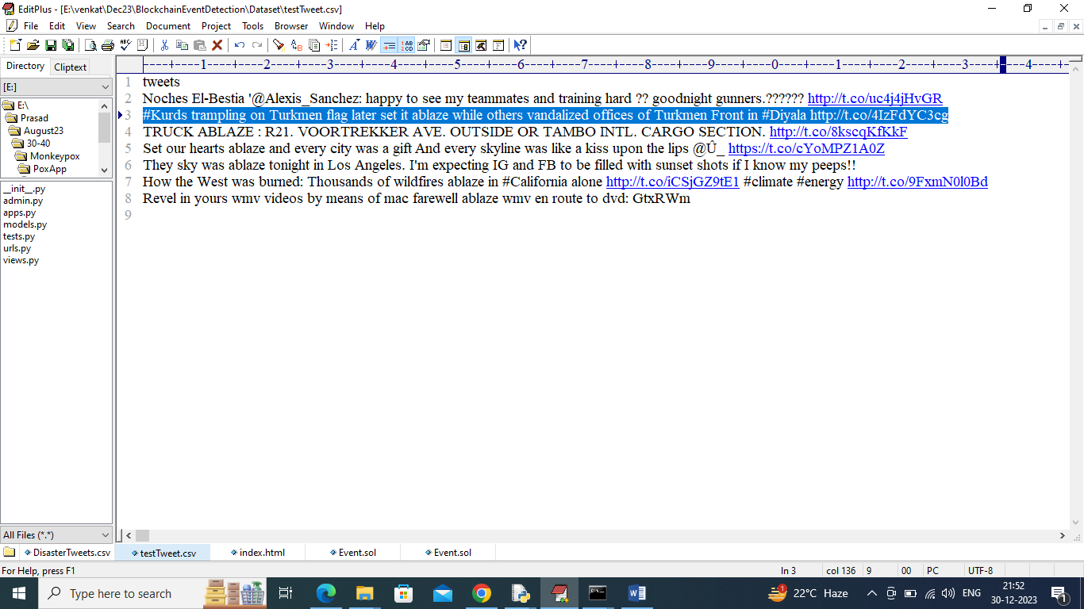
In above screen copying some tweets and paste in below screen
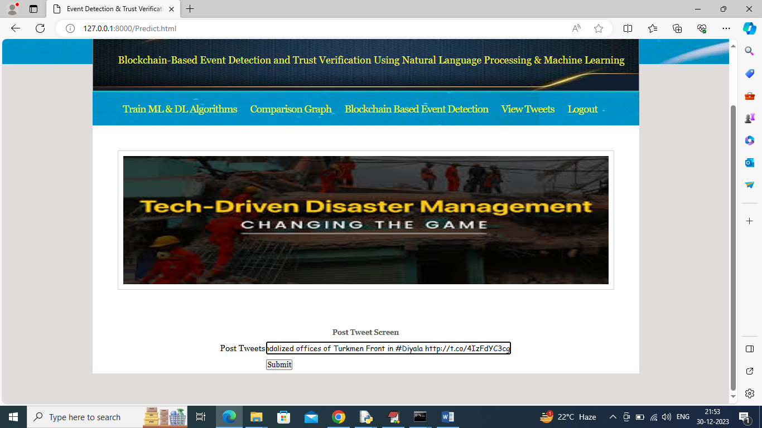
In above screen pasting copied tweet and then click on ‘Submit’ button to get below output
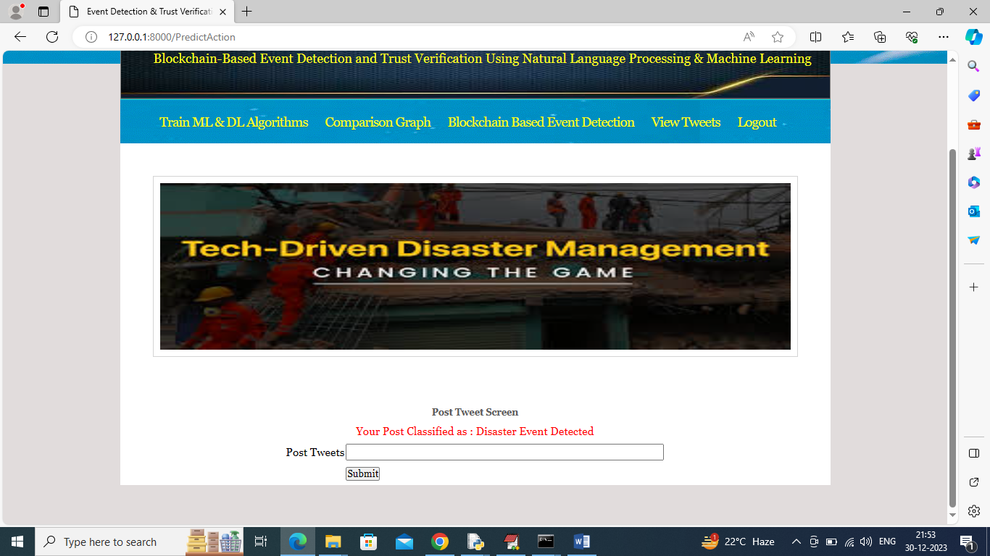
In above screen in red colour text can see post classification result and this result will get saved in Blockchain. Similarly you can test other tweets and below are the other example
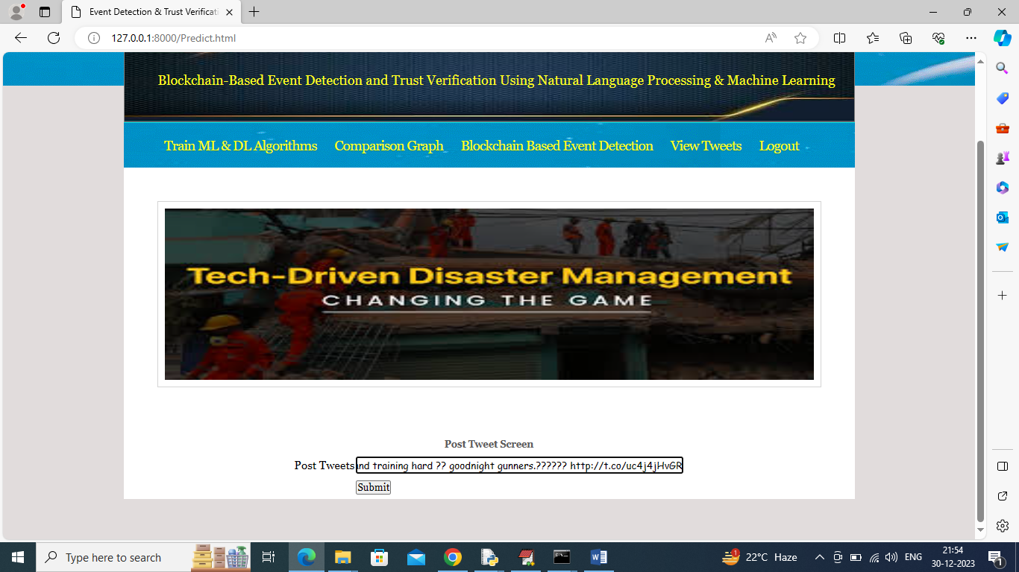
In above screen entered some other tweet and below is the output
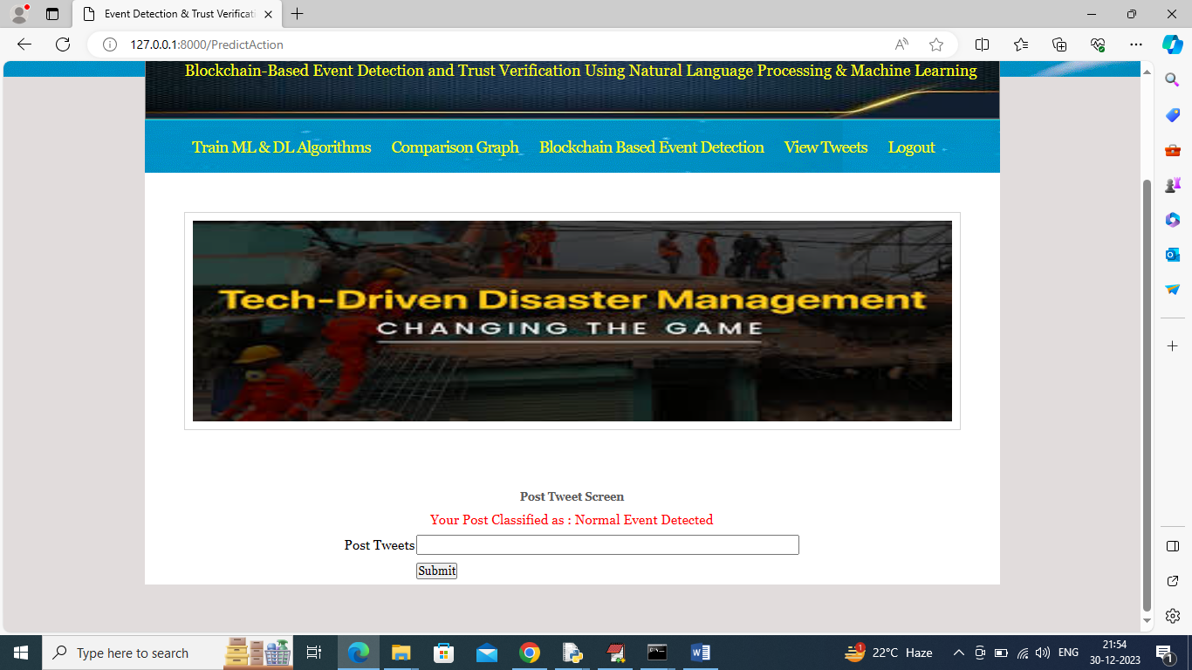
In above screen tweet classified as ‘Normal Event’ and now click on ‘View Tweets’ to get all tweets from Blockchain like below screen
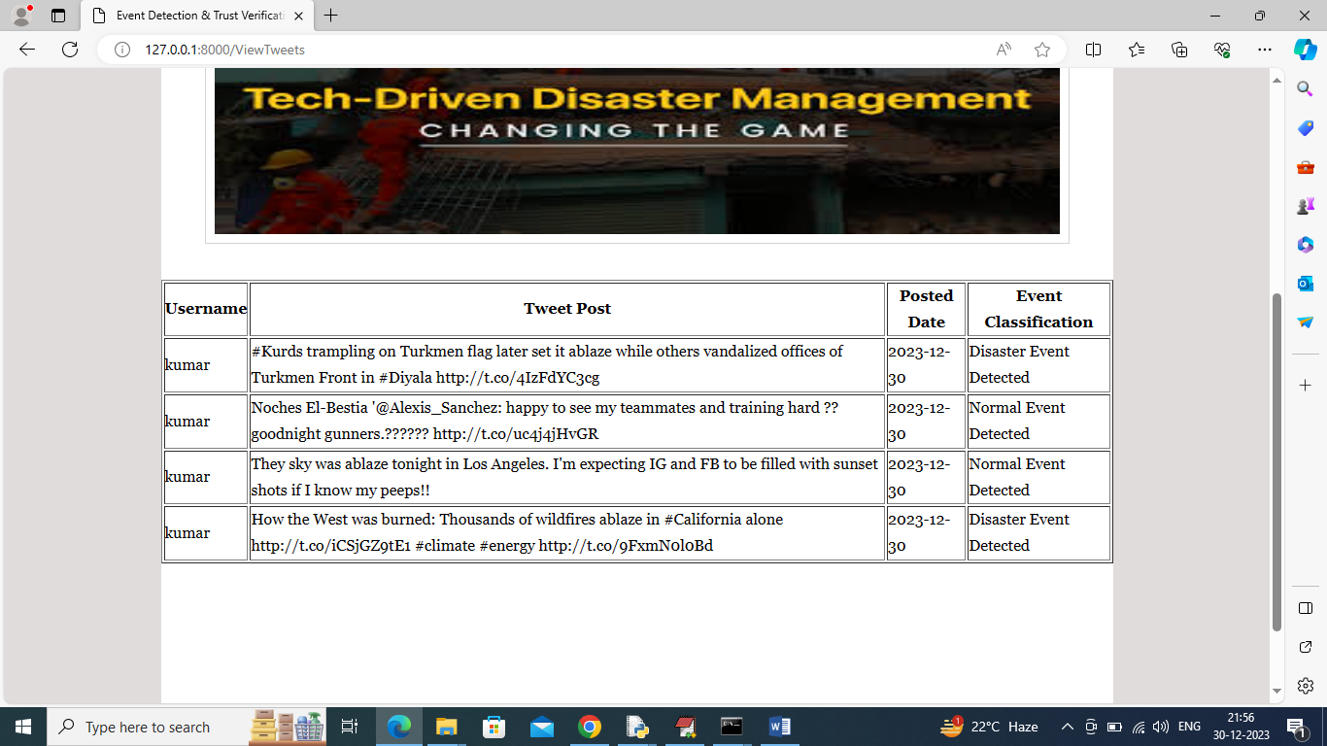
In above screen all users can see ‘tweets’ uploaded by different users and can see tweet message, date and predicted event type. All the above tweets are fetching from decentralized Blockchain servers.
Similarly you can add any number of tweets which will saved in Blockchain and ML will classify tweets event type.

Conclusion:
In conclusion, the Blockchain-Based Event Detection and Trust Verification project represents a groundbreaking initiative to address the challenges associated with the reliability of event information on social media. By combining Blockchain's decentralized and tamper-proof architecture with the analytical capabilities of NLP and ML, the proposed system offers an automated and secure solution for event detection and trust verification. The implementation of smart contracts further streamlines the validation process, providing users with a trustworthy and transparent mechanism to verify the authenticity of shared events. This project contributes to the development of more reliable information ecosystems, fostering a safer and more informed online community.

References:
- P. Williams, "Crisis management" in Contemporary Strategy, Evanston, IL, USA:Routledge, pp. 152-171, 2021.
- L. Ardito, M. Coccia and A. M. Petruzzelli, "Technological exaptation and crisis management: Evidence from COVID-19 outbreaks", RD Manage., vol. 51, no. 4, pp. 381-392, Sep. 2021.
- J. Abbas, D. Wang, Z. Su and A. Ziapour, "The role of social media in the advent of COVID-19 pandemic: Crisis management mental health challenges and implications", Risk Manag. Healthcare Policy, vol. 14, pp. 1917, May 2021.
- S. Wang, Z. Yang and Y. Chang, "Bringing order to episodes: Mining timeline in social media", Neurocomputing, vol. 450, pp. 80-90, Aug. 2021.
- S. G. Arapostathis, "A methodology for automatic acquisition of flood-event management information from social media: The flood in Messinia South Greece 2016", Inf. Syst. Frontiers, vol. 23, pp. 1127-1144, Jan. 2021.
- A. Kruspe, J. Kersten and F. Klan, "Detection of informative tweets in crisis events", Natural Hazards Earth Syst. Sci., 2021, [online] Available: https://nhess.copernicus.org/articles/21/1825/2021/.
- M. Fedoryszak, B. Frederick, V. Rajaram and C. Zhong, "Real-time event detection on social data streams", Proc. 25th ACM SIGKDD Int. Conf. Knowl. Discovery Data Mining, pp. 2774-2782, Jul. 2019.
- F. Jamil, L. Hang, K. Kim and D. Kim, "A novel medical blockchain model for drug supply chain integrity management in a smart hospital", Electronics, vol. 8, pp. 505, Apr. 2019.
- F. Jamil, S. Ahmad, N. Iqbal and D.-H. Kim, "Towards a remote monitoring of patient vital signs based on IoT-based blockchain integrity management platforms in smart hospitals", Sensors, vol. 20, no. 8, pp. 2195, Apr. 2020.
- B. Zaabar, O. Cheikhrouhou, F. Jamil, M. Ammi and M. Abid, "HealthBlock: A secure blockchain-based healthcare data management system", Comput. Netw., vol. 200, Dec. 2021.
- F. Jamil, F. Qayyum, S. Alhelaly, F. Javed and A. Muthanna, "Intelligent microservice based on blockchain for healthcare applications", Comput. Mater. Continua, vol. 69, no. 2, pp. 2513-2530, 2021.
- F. Jamil, H. K. Kahng, S. Kim and D.-H. Kim, "Towards secure fitness framework based on IoT-enabled blockchain network integrated with machine learning algorithms", Sensors, vol. 21, no. 5, pp. 1640, Feb. 2021.
- I. Jamal, Z. Ghaffar, A. Alshahrani, M. Fayaz, A. M. Alghamdi and J. Gwak, "A topical review on machine learning software defined networking Internet of Things applications: Research limitations and challenges", Electronics, vol. 10, no. 8, pp. 880, Apr. 2021.
- F. Jamil and D. Kim, "Enhanced Kalman filter algorithm using fuzzy inference for improving position estimation in indoor navigation", J. Intell. Fuzzy Syst., vol. 40, no. 5, pp. 8991-9005, Apr. 2021.
- F. Jamil, O. Cheikhrouhou, H. Jamil, A. Koubaa, A. Derhab and M. A. Ferrag, "PetroBlock: A blockchain-based payment mechanism for fueling smart vehicles", Appl. Sci., vol. 11, no. 7, pp. 3055, Mar. 2021.
- F. Jamil and D. H. Kim, "Improving accuracy of the alpha–beta filter algorithm using an ANN-based learning mechanism in indoor navigation system", Sensors, vol. 19, no. 18, pp. 3946, 2019.
- M. H. Bin Waheed, F. Jamil, A. Qayyum, H. Jamil, O. Cheikhrouhou, M. Ibrahim, et al., "A new efficient architecture for adaptive bit-rate video streaming", Sustainability, vol. 13, no. 8, pp. 4541, Apr. 2021.
- I. Jamal, F. Jamil and D. Kim, "An ensemble of prediction and learning mechanism for improving accuracy of anomaly detection in network intrusion environments", Sustainability, vol. 13, no. 18, pp. 10057, Sep. 2021.
- F. Jamil and D. Kim, "Payment mechanism for electronic charging using blockchain in smart vehicle", Korea, vol. 30, pp. 31, May 2019.
- I. Jamal, N. Iqbal, S. Ahmad and D. H. Kim, "Towards mountain fire safety using fire spread predictive analytics and mountain fire containment in IoT environment", Sustainability, vol. 13, no. 5, pp. 2461, Feb. 2021.

